Twinkling Christmas Stars
On day one and two of creation, God made light and darkness. On day four, God made the sun, the moon and the stars. The sun to shine in the day, and the moon and stars to shine in the night, to bring light into the darkness!
Ephesians Chapter 5 v 8 says “For you were once living in darkness (before we knew Christ) but now you are living in the light (now we have accepted Christ), so live as children of light!
Just like these glow-in-the-dark stars which shine bright in the darkness of night, we need to be like these stars, by reflecting the Light (and love) of Jesus into our schools, our homes, our workplaces!

Action
Take one of these stars and write your name on it and stick it onto the black curtain.
Reflection
Now spend a little while in prayer asking The Lord to show you how you can reflect Jesus’ light into your situation. If you want you can write down what Jesus tells you on a card.
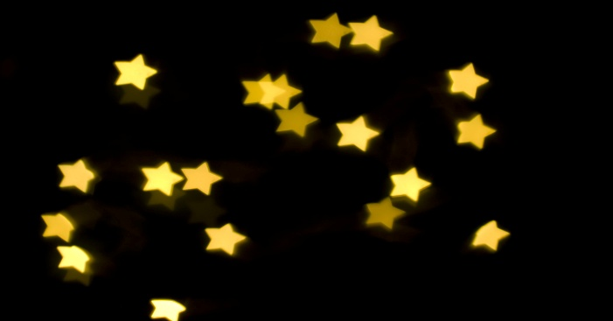
This Photo by Unknown Author is licensed under CC BY

